Guided Capstone Project Report: Ski Resort Pricing Model
Ray Karpman

Background

Big Mountain Ski Resort has offers beautiful views, over 100 trails, and an impressive vertical drop of 2,353 feet. Historically, Big Mountain has charged a premium above the average price for resorts in its market segment. This simple approach does not take into account how specific features impact customer preference. Going forward, Big Mountain would like to pursue a more data-driven pricing strategy. Big Mountain is also interested in exploring strategic improvements to their facilities that would justify higher prices.
To address these problems, we built a predictive model which gives the market price for a ski resort, using data about the resort’s facilities. The model can be used to set data-driven prices, and explore the impact of various new investments or cost-cutting strategies on market price.

Recommendations

Our model suggests that Big Mountain’s tickets are under-priced. The current price of a weekend day at Big Mountain ticket is $81, while the predicted price is $95.87. Model predictions are not exact; on average, predictions from the model are off by $10.39 in either direction. Taking this error into account, we recommend Big Mountain increase ticket prices to $85 dollars, and consider further price increases in the future.
We modeled several strategies for either cutting costs, or adding features to raise prices. In all of our models, we assumed the Big Mountain would continue to have 350,000 visitors per season, with visitors buying an average of five day tickets each. We suggest Big Mountain consider two possible strategies: closing less-used runs to reduce operating costs, and adding a new run to increase vertical drop.
We found that Big Mountain could close one run with no loss of revenue. Closing two runs reduces predicted price by $0.40, which translates to $700,000 in lost revenue. Closing three runs reduces predicted price by a total of $0.66, for a revenue loss of $1,155,000. There is no additional loss from closing up to five runs. If the projected cost savings outweigh the projected decrease in revenue, Big Mountain should consider successively closing one, two, and five runs, and evaluating the impact on profits at each step.
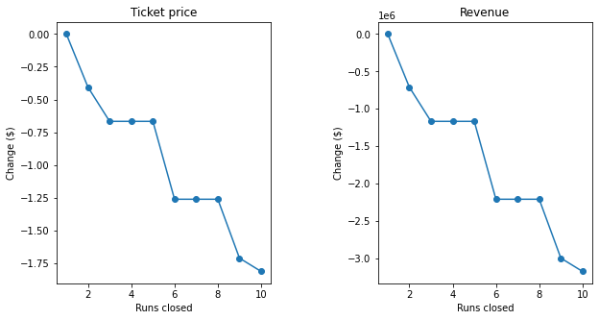
As an alternate strategy, Big Mountain should consider adding a new run, which would increase the vertical drop by 150 feet, and installing an additional chair lift to service the new run. These changes would support a ticket price increase of $1.99, which could translate into over 3.47 million dollars of additional revenue over the season. The additional revenue would be more than enough to cover the operating costs from the new chair lift, which approximately 1.54 million dollars, leaving Big Mountain with a profit of approximately 1.93 million dollars.
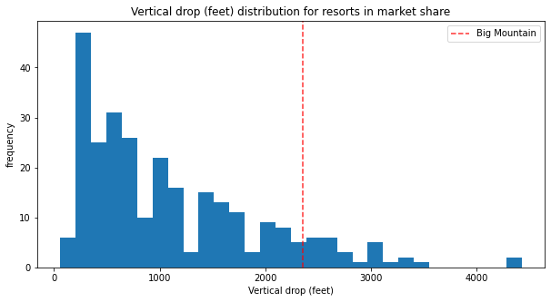
Modeling and Analysis

Our model uses a random forest algorithm, which we trained using data from 276 ski resorts in Big Mountain’s market segment. We considered twenty-one numerical features. These included such as vertical drop, snow-machine coverage, total number of runs, days open, and number of various types of lifts. Assuming that most resorts are setting prices that maximize their profits, our model predicts the optimal price for Big Mountain.
We considered two modeling strategies: linear regression, and a random forest algorithms. When trained on the available data, the random forest model was both more accurate and more consistent. The model identified four features which are especially important. These features, in descending order, are number of fastQuads (fast, four-person lifts), total runs, acres covered by snow machines, and vertical drop. We note that all four of those features were identified as significant predictors of higher price in our linear model as well, strongly suggesting that our model is capturing real consumer preferences.
Compared to resorts in its market share, Big Mountain scores highly on all four of our key features, which helps explain its high predicted ticket price. However, as seen in the figure below, there are many resorts with larger vertical drop, suggesting that this is a feature Big Mountain could improve. Recall that adding a run to increase vertical drop was one promising strategy to boost Big Mountain’s ticket price.

Given that Big Mountain is currently the highest priced resort in Montana, raising prices may seem risky. However, our model suggests that it is more appropriate to consider the market price for the entire United States. While exploring the data, we investigated potentially relevant characteristics of US states, including size, population, and density of ski resorts. Even taking these variables into account, we found no significant relationship between location and price. Hence we may consider Big Mountain’s price in the context of the US as whole, where prices above Big Mountain’s $81 are relatively common, as seen in the figure below.
